**ONLINE SECURITY MANAGEMNET SYSTEM**

**QUESTION:**

A college has more than thousand security persons, who are instructed to give duties at different places within the campus. Additionally, they also maintain a routine, which contains all information, such as Date, Duty Start Time, Duty End Time, and Place. Most importantly, all the places are covered by at least one security person. If a security person takes leave, manual entry is done against that person. Finally, at the end of a month, the security persons get paid for their duties, while considering the number of leaves as well. You can see that the manual calculation/operation is a heavy task for the security manager. Therefore, the objective is to build an Online security management system using class diagram through which entire security system within the campus can be controlled in an efficient manner

**AIM:**

To develop a **Class Diagram** for an **Online Security Management System** that efficiently manages security personnel, duty schedules, leave tracking, and payroll within a college campus.

**PROCEDURE:**

1. Identify classes: SecurityPerson, DutySchedule, LeaveRecord, PaymentSystem, Admin.

2. Define attributes & methods for each class.

3. Establish relationships between classes.

4. Draw the Class Diagram with attributes, methods, and associations.

**DIAGRAM:** 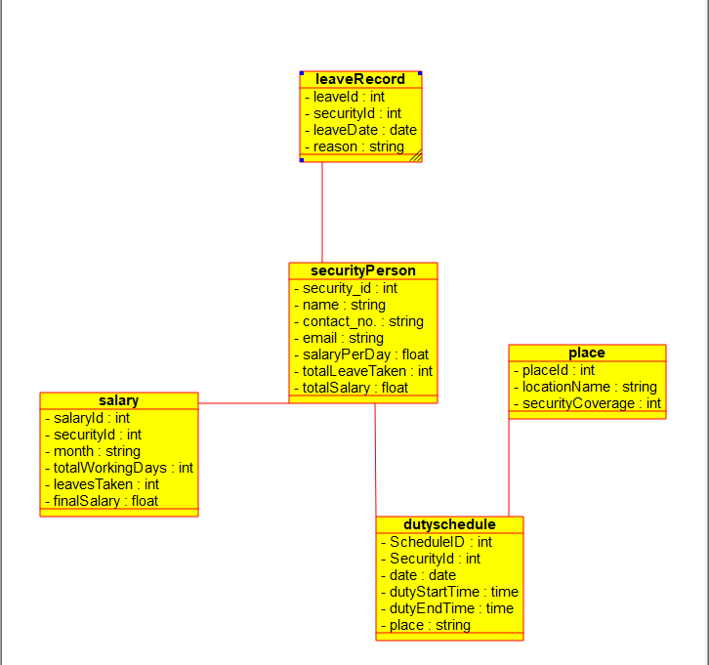

**RESULT:**

A **Class Diagram** for the **Online Security Management System** was successfully created.